

Submitted by : Spogmai jan

Roll no: 2430 -0081

Submitted to : Sir Bilal khan

Subject : OOP LAB

**Assignment no :05**

Task 01:

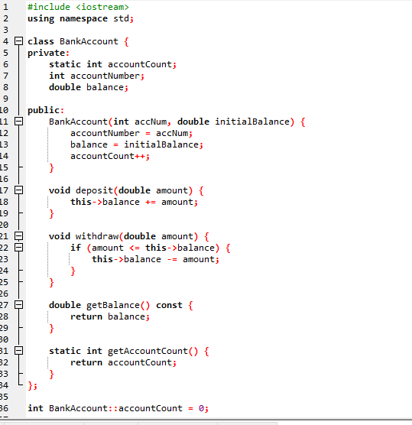

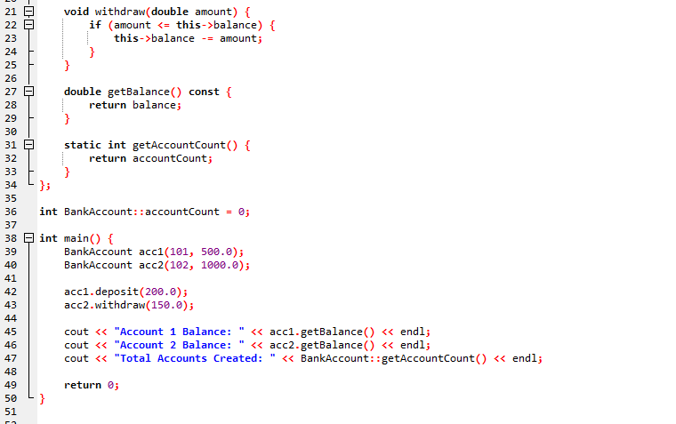

OUTPUT

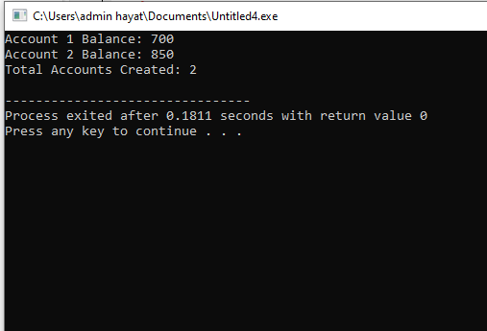

Task 02:

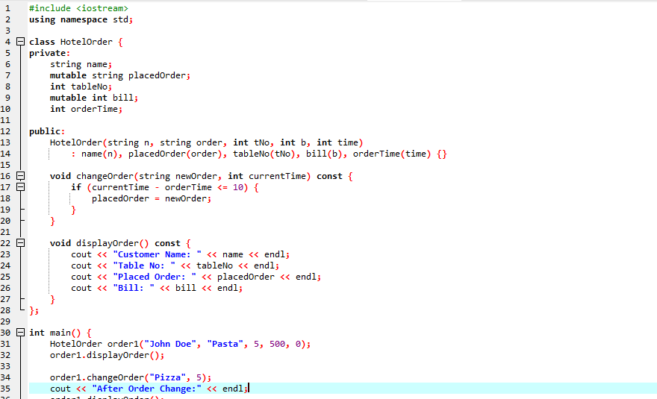

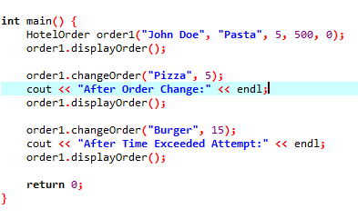

**OUTPUT:**



